Code Review: I2305166
Reviewer: James Wood
Date: July 12th, 2023

Bugs

Preventative Action/Safety

Design/Architecture (Duplication, appropriate project, namespaces, maintainability)

Data Model (Naming, good design, needs index?)

Performance (Minimize DB hits, excessive loops, queries, scalable)

UI (Alignment, naming, standardization, tab order)

Error Handling (Behind events, appropriate parameter checking)
- It looks like you cleaned up uses of On Error Go To, which is great(good job on that), but in this place it looks like we’re no longer throwing the exception. Is this intentional?
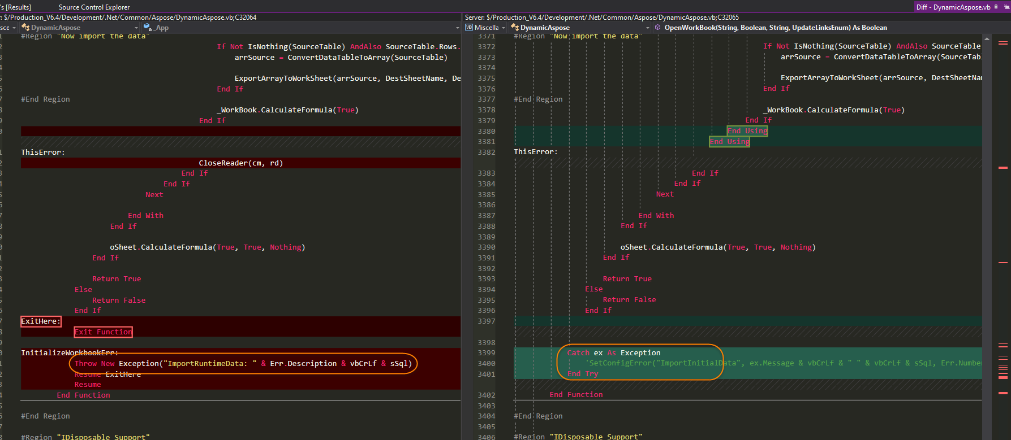
- We should not be displaying message boxes from non-UI classes/objects. Only forms(and controls) should be displaying message boxes. Everything else should be throwing exceptions or handling the exceptions themselves.

- This DataTable and DataSet in ImportRuntimeData are not being cleaned up:
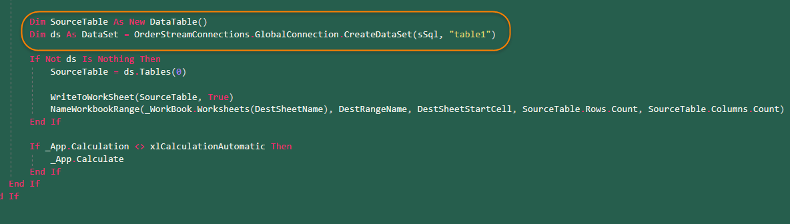

Cleanup (Dispose code, remove handlers, large data objects)
- Have you ran this through DLLs yet? I think what you’d see is at least one Excel instance left over in Task Manager. This is because there are many Excel objects that are created but not cleaned up.
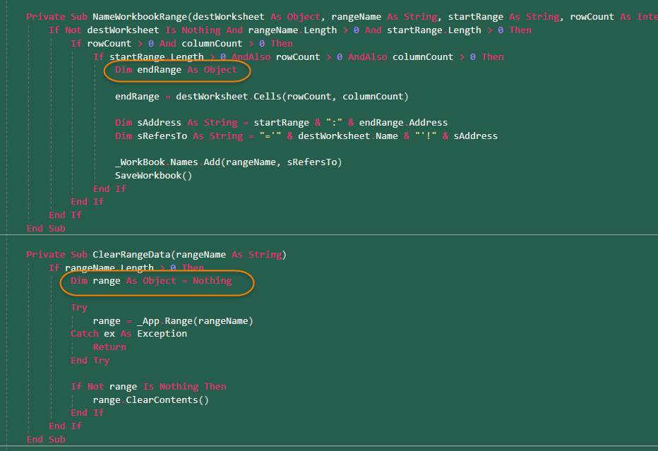
Any code creates these objects also needs to clean them up. But this is also the case for implicitly created objects, when multiple qualifiers are used in one line:
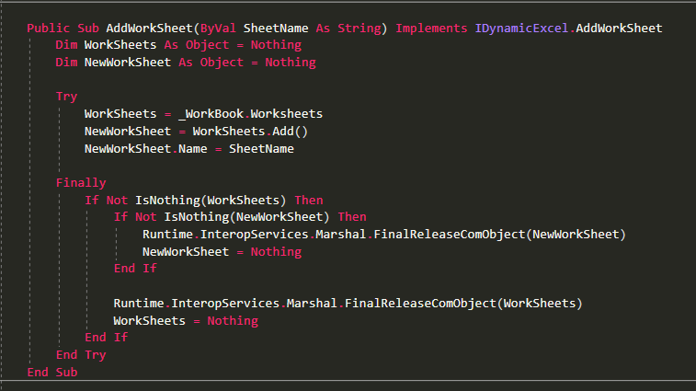
Note that both WorkSheets and NewWorkSheet have to be cleared in the Finally. This ensures full clean up of the resources used by the method.
Also note that the first two lines are split up:

WorkSheets = _WorkBook.Worksheets
NewWorkSheet = WorkSheets.Add()
Instead of…
WorkSheets = _WorkBook.Worksheets.Add()
This is because when you call the WorkBook.Worksheets.Add() method, a WorkSheets COM object gets created in the background, but because it’s not being referenced by any code, there’s no way to actually clean it up at the end. So, for safety, anything that references multiple levels of properties, should be split up so each level can be referenced and cleaned up.
When cleaning up, be sure to use the clean up method shown above, FinalReleaseComObject().

Readability (Well-named variables, methods, clear algorithm, is it understandable)
- We are trying to follow the Microsoft .Net standards, with the use of Is/IsNot Nothing. The Not … Is Nothing method is no longer recommended, as per Microsoft’s standards:
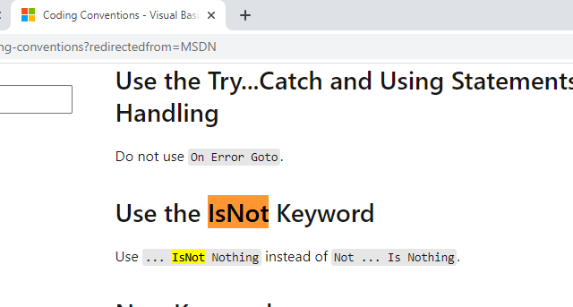
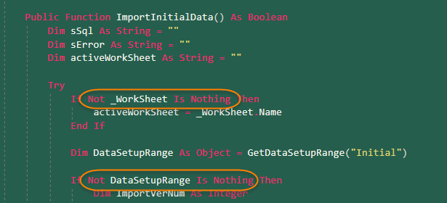
Please correct all instances of this.
- Using the method name to return a value is no longer the proper way to do it. Use Return statements instead(Return True):
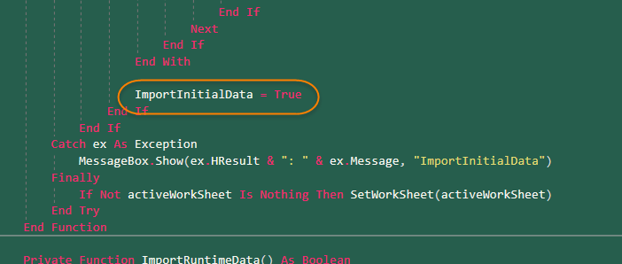
- The .Net Framework has some built-in methods to help parse file names. The System.IO.Path class can you help extract the file name very easily:
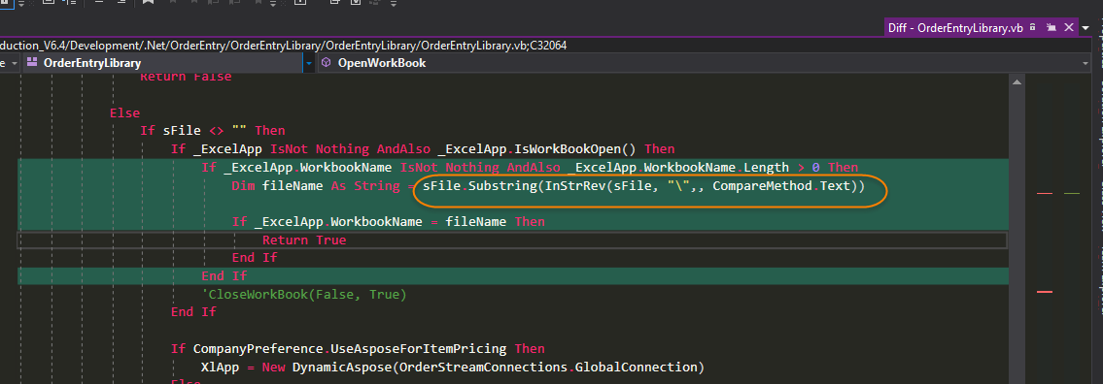
Instead of manually parsing the whole file path, use the System.IO.Path class, as this will be easier to read for future developers, but also much safer.
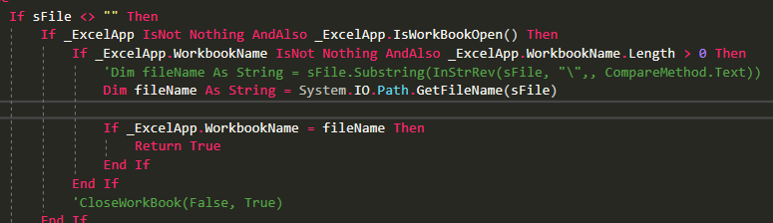
- I know that this is faster as once it’s found oRange, it won’t check anymore, but think having the If statements individually is preferred, similar to how the below Case statements handle it.
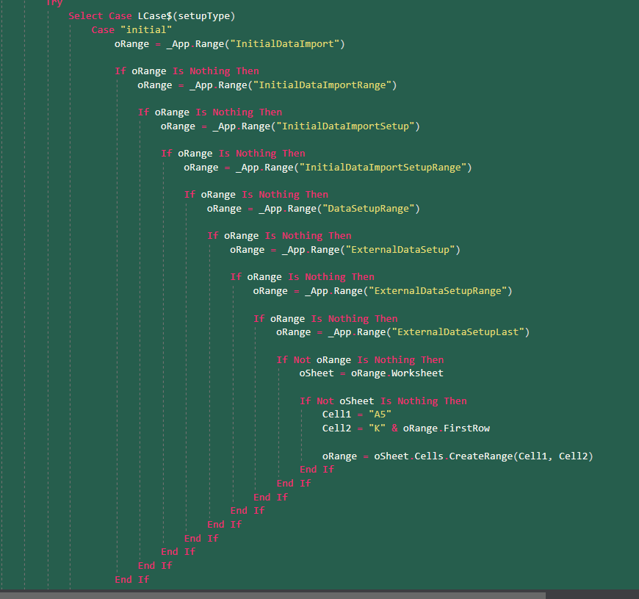

- Remove all uses of IsNothing(). This is an outdated construct. Is Nothing or IsNot Nothing are the modern .Net versions.
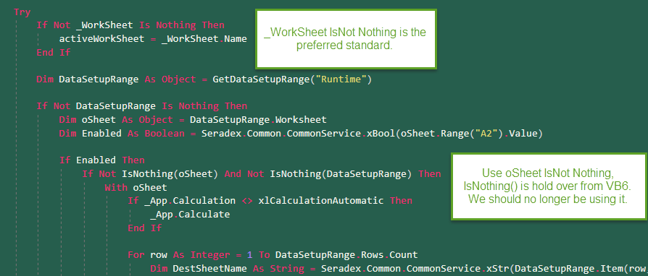

Comments (Useful, explains why rather than how)

Message Boxes (Grammar, spelling, captions, appropriate icons)

Ticket Management (Release Branch?, Testing Notes)
- It appears that you checked in some Code Review changes for another ticket in with this ticket’s changes. Please keep these separate and check in code review changes against the original ticket’s work item. Checking both in under the same work item makes it’s impossible to know what’s already been reviewed and what hasn’t.

Extras

